Overview
 |  | GridET User’s Manual Version 1.1  Updated August 2018
GridET was developed to estimate evapotranspiration—or the evaporation of water off the land surface and through plant transpiration—at a high spatial resolution covering a large area. Originally developed for the state of Utah and the arid climate conditions prevalent in the American West, GridET can download and process publicly available raster datasets encompassing the continental United States and much of North America. Program outputs include:
◆ Open water evaporation
◆ Reference evapotranspiration (the hypothetical amount of water use a given plant would require in healthy and well-watered conditions)
◆ Potential evapotranspiration (maximum likely evapotranspiration of a vegetation and/or land surface; e.g., 2nd or 3rd year alfalfa stand at top performance in 1/10 years)
◆ Net potential evapotranspiration (potential evapotranspiration minus effective precipitation; net irrigation requirement)
◆ Climate variable inputs (solar radiation; air temperature, humidity, and pressure; wind vectors; and precipitation)
Estimate averages or summations are stored as images in binary format on a daily time step, which are then totaled to monthly, annual, and period statistics. A built-in spatial function translates the raster output into vector polygon averages for further analysis and inspection. GridET is able to automate many of these tasks, which in turn allows the user to focus more on actual results and lessens the need for more expensive computing hardware as the calculations are ongoing. Future expansion and custom routines are planned for and supported by a flexible program input and output structure.

Domain
GridET, as was the case in its forerunner UtahET (Hill et al., 2011), was funded by the Divisions of Water Resources and Water Rights within the Utah Department of Natural Resources for use within Utah. Particular attention was given to irregularities in climate and terrain inherent in this state and adjustments applied in estimating evapotranspiration. Daily and seasonal calibrations were obtained by comparing weather station measurements within the state to input meteorological datasets. Although concentrated on Utah, the current configuration (Version 1.1) would also be applicable to neighboring intermountain states of Nevada, Colorado, Idaho, and up to Montana but would overestimate evapotranspiration in Arizona and New Mexico without adjustments. Supported input datasets span the continental United States, and so GridET could be modified to surrounding states with appropriate calibrations.
There are other limitations to the intended scope and design of the software. Potential evapotranspiration output of a user-defined land cover is calculated over the entire area of interest, but it is only valid in representing contributing areas of like land cover and fully irrigated conditions. Drought, plant sickness, water quality, or other factors may reduce a land cover’s evapotranspiration from the potential, which fraction of the potential or real condition has been denominated actual evapotranspiration. Except for when it reaches potential evapotranspiration, GridET does not output actual transpiration. Inputs and outputs are estimates that have been generated by a model and should be judiciously assessed for accuracy. This means that the user should be familiar with the concepts and practice of estimating evapotranspiration in order to correctly interpret the results.
GridET and its dependencies have been tested to run on Windows and Linux, but its output file formats are platform independent enabling shared access to calculated results. It was written in Visual Basic .NET using Microsoft Visual Studio 2010 Express edition, targets the .NET 4.0 Framework, and can be compiled for x86 or x64 architectures. For greater understanding of evapotranspiration calculations, input datasets, or other program features, the user is directed to previously published material located in the reference section or ultimately the released source code.

License
This software may be used for the benefit of all. It is hoped that it will be a foundation upon which to build scientific tools. To avoid any entanglements by placing it in the public domain, the permissive Boost license was selected. As both dependencies’ source code, GDAL and SQLite, are also under permissive licenses, these should not hinder use. One note is that many of the libraries that GDAL relies upon are under different licenses.
Boost Software License - Version 1.0 - August 17th, 2003
Permission is hereby granted, free of charge, to any person or organization obtaining a copy of the software and accompanying documentation covered by this license (the "Software") to use, reproduce, display, distribute, execute, and transmit the Software, and to prepare derivative works of the Software, and to permit third-parties to whom the Software is furnished to do so, all subject to the following:
The copyright notices in the Software and this entire statement, including the above license grant, this restriction and the following disclaimer, must be included in all copies of the Software, in whole or in part, and all derivative works of the Software, unless such copies or derivative works are solely in the form of machine-executable object code generated by a source language processor.
THE SOFTWARE IS PROVIDED "AS IS", WITHOUT WARRANTY OF ANY KIND, EXPRESS OR IMPLIED, INCLUDING BUT NOT LIMITED TO THE WARRANTIES OF MERCHANTABILITY, FITNESS FOR A PARTICULAR PURPOSE, TITLE AND NON-INFRINGEMENT. IN NO EVENT SHALL THE COPYRIGHT HOLDERS OR ANYONE DISTRIBUTING THE SOFTWARE BE LIABLE FOR ANY DAMAGES OR OTHER LIABILITY, WHETHER IN CONTRACT, TORT OR OTHERWISE, ARISING FROM, OUT OF OR IN CONNECTION WITH THE SOFTWARE OR THE USE OR OTHER DEALINGS IN THE SOFTWARE.

Installation
GridET space requirements are ~100 MB, and recommended available RAM is at least 2 GB—although the amount required is directly a function of the size of the dataset(s) being processed. Available storage space should number in the terabytes for a typical project area. GridET can installed as a regular program through the setup executable or be run from source (which is recommended if any experimental routines have been added). Installation files were created via an Inno Setup script. The setup is generic in nature: accept the license, verify the installation directory, and show installation progress to the user.
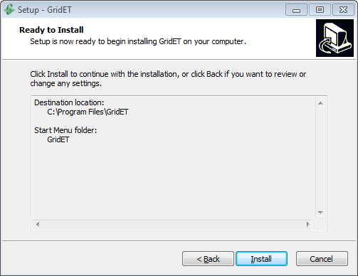
Screenshot 1. GridET Installation Routine

GridET Project
A GridET project consists of a directory containing subdirectories and files pertaining to a given region and grid resolution. Within the first level of the project directory is a database file named ‘Project Details.db’ that stores project options, user input data, and represents what is otherwise known as a save file. It also contains the full path to a climate dataset directory, which holds the downloaded climate datasets or input datasets. To conserve space and bandwidth, the climate dataset directory may be shared among multiple projects, but an individual climate dataset may only be updated by one project at a time. This is a limitation of the database, which is later discussed.
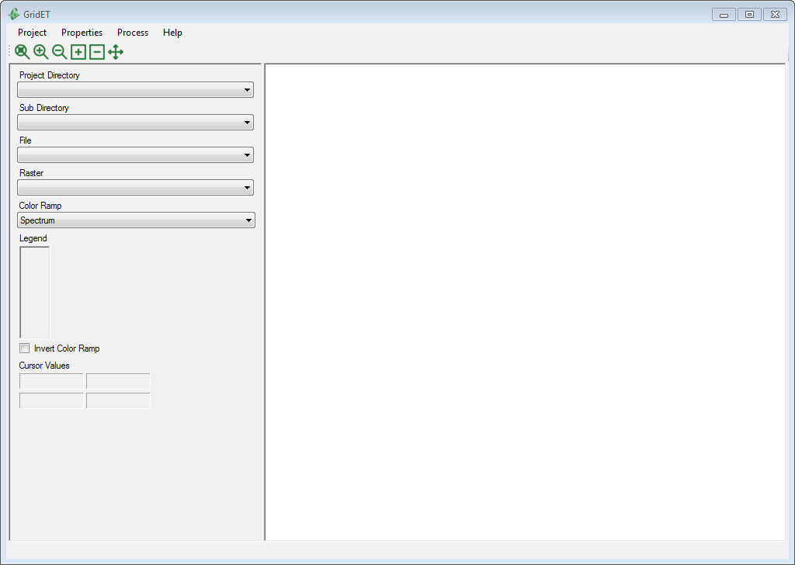
Screenshot 2. GridET Startup Window

New Project
To create a new GridET project, the user navigates the [Project] menu and selects the [New] button. A dialog opens that requires six inputs.
Project Directory Path
Full path of the project directory, which may be added from the [Set] dialog.
Climate Model Directory
Full path of the climate model directory, which may be added from the [Set] dialog.
Mask Dataset Path
Full path to a polygon vector dataset representing the project area of interest. Vector formats in GDAL 2.0 are supported minus some externally linked libraries (which includes ESRI File Geodatabase). The project area is created by rasterizing each polygon within the vector dataset (which also effectively dissolves the dataset into one feature). This output project template raster uses the vector dataset spatial reference system. Currently (Version 1.1), only areas within the conterminous United States are supported.
Project Raster Resolution
Resolution of project area in mask dataset spatial reference system units. This value determines the number of raster pixels, in which a smaller value corresponds to a greater number pixels and proportional processing time.
Elevation Dataset Path(s)
Full path(s) to digital elevation model raster(s) enclosing the mask dataset region with an adequate buffer along the edges for a determinant slope calculation. If multiple files are added, they will be merged into a temporary intermediate dataset upon project creation.
Vertical Scaling Factor
Conversion factor of elevation dataset z-factor to feet (above mean sea level).
Once the required input has been entered, the user then clicks [Create] to start the new project creation. Project creation is relayed to the user via messages and a progress bar, and operation time may range from a few minutes to many hours depending on dataset size, selected resolution, and elevation raster format. The process may be terminated at any time; however any created (or partially-created) files will remain.
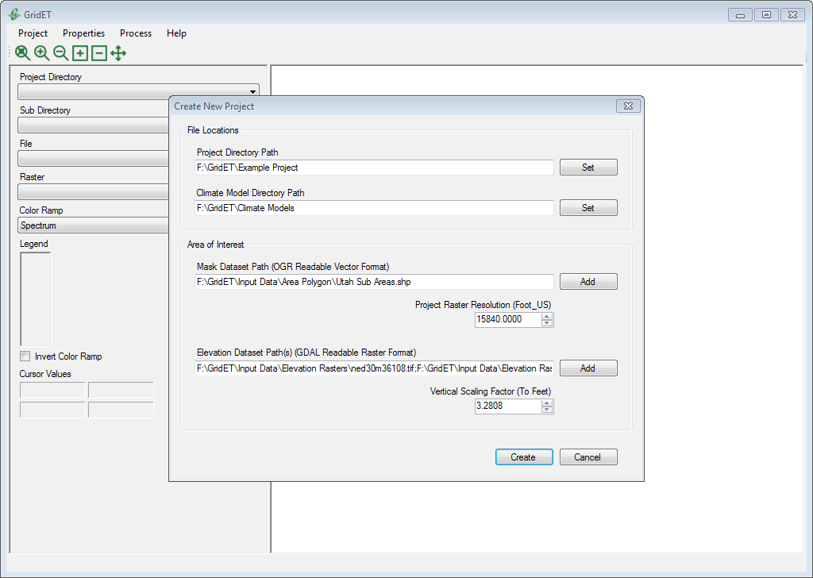
Screenshot 3. Example Project Creation with Mask Dataset Centered on Utah, National Elevation Dataset Tiles, and Resolution of 3 Miles
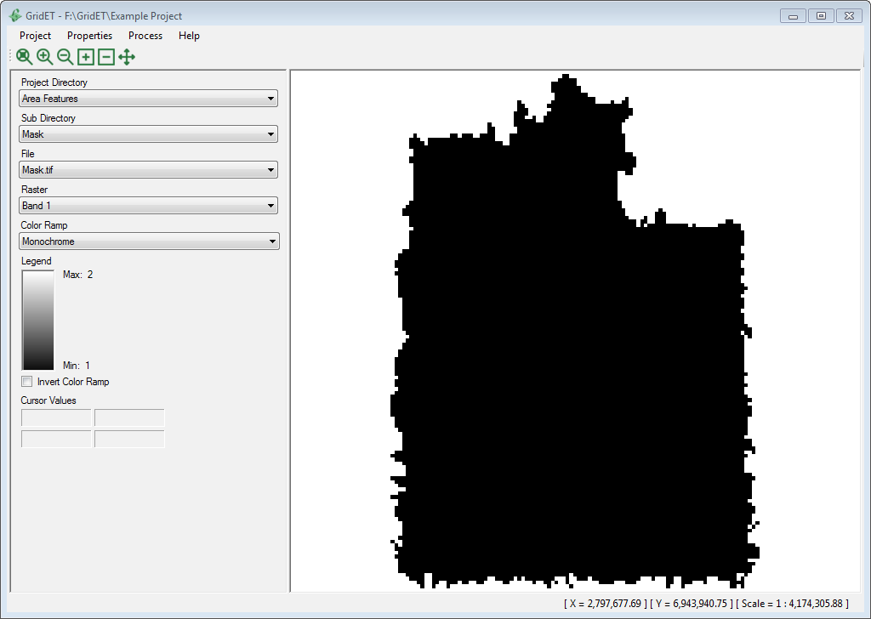
Screenshot 4. Example Project Output Mask Centered on Utah

Directory Structure
A GridET project is made up of three hierarchal levels of directories. Level 1 is the project level directory, which includes the project details file, temporary files, and second level subdirectories. Level 2, itself, contains no files but groups the third level into project area features directories, calculation directories, and output directories. Level 3 contains vector shapefiles, projection files, database files, and custom raster files. One clarification in the following screenshot is that Level 3 Output Calculation directories are added upon creation for different time period calculations.
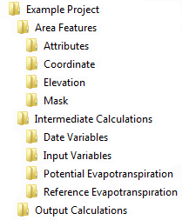
Screenshot 5. Example Project Tiered Directory Structure

Raster Storage
GridET stores the many thousands or millions of downloaded rasters that may be calculated in a project scenario in SQLite3 databases. A database is created for each climate dataset with a page file size of 4,096 bytes which equates to a maximum database size of 8 terabytes. This option is hard coded but could be adjusted (which would also require rebuilding existing databases) to the maximum allowed size of 128 TB. Currently, the original setting is more than sufficient. SQLite3 was selected as the RDBMS because of its permissive license, portability of output, widespread use, speed, ACID compliance, and elimination of a central database server. One downside is that it locks at the file level and only supports one writer at a time (reader unlimited), which doesn’t easily coordinate well on a shared network drive.
Intermediate calculation rasters output from GridET are appended (Version 1.1) to a custom raster array file per variable. The output raster format is scaled from 32 bit floating point to 16 bit unsigned integers. Further, all ‘no data’ raster values have been removed leaving a (most likely) reduced size. No compression mechanism was added as the file system was expected to provide transparent compression. Metadata and offsets to each raster in the array are stored in an accompanying SQLite database. In Version 1.0, intermediate calculation rasters were stored as GeoTIFF images in a SQLite database, but simple arrays proved to be much easier to manage, faster, and removed reliance on an external library that was found to not be threadsafe.
 |  | SQLite  http://sqlite.org/  License: Public Domain
One (of many) open source SQLite database manager that may be used externally from GridET to inspect and manipulate the SQLite database files is DB Browser for SQLite. Since it loads a defined number of rows when reading a table to the RAM, it becomes unusable when the database grows large with even low resolution images if the default row import setting is not changed. Once this condition is reached or for a more complex analysis, a custom query may be preferred.
 |  | DB Browser for SQLite  http://sqlitebrowser.org/  License: Mozilla Public License Version 2  OR GNU General Public License Version 3 or later
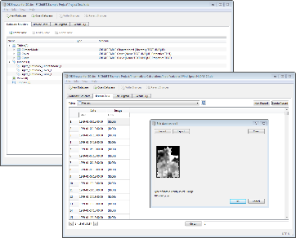
Screenshot 6. GridET SQLite Database Interaction within DB Browser for SQLite

Geospatial Calculations
GDAL is the backbone for reading and writing of external raster and vector files within GridET. Further, its utility programs are incorporated to create custom geoprocessing functions. GDAL supports at least reading of most of the prevalent geospatial formats, is a lead library in the Open Source Geospatial Foundation, and is included in many GIS-oriented projects. As a conglomeration of libraries, it has differing but mainly open source linked libraries that can be included in a given build. GridET is set up to include nearly every library except for the externally linked ones. Another (software) restriction is no support for a database/table input within dialogs in GridET so that input must be in single (or multiple) file format within a directory. The GDAL version 2.3 is the current build in GridET (Version 1.1).
 |  | Geospatial Data Abstraction Library (GDAL)  http://gdal.org/  License: X11/MIT
QGIS is a project that exposes GDAL libraries and functions through a graphical user interface that can also be used as a default open source viewer for GridET output. In reality, GridET could have been coded as an add-on for QGIS, but the stability of separate product was preferred. In any case, it may be used to view and manipulate output from GridET.
 |  | QGIS (formerly Quantum GIS)  http://qgis.org/  License: GNU General Public License Version 2 or later

Units
Although GridET internally accounts for a plethora of unit conversions combining climate dataset input and scientific formulae, the user should be aware of the relatively few and standardized input and output units. Generally, U.S. customary units were the chosen system. Units for GridET are defined in the following table.
Table 1. GridET Input and Output Units
Parameter | Unit
Aspect | Decimal Degrees Clockwise from North
Coordinate Reference System | Any GDAL Supported
Dates | Integer Day of Year
Elevation | Feet
Growing Degree Days | Fahrenheit Degrees
Latitude and Longitude | Decimal Degrees
Potential Evapotranspiration | Inch
Precipitation | Inch
Reference Crop | Alfalfa or Long Reference
Reference Evapotranspiration | Inch
Slope | Decimal Degrees Upwards from Horizontal
Solar Radiation | Langley
Temperature | Degrees Fahrenheit
Wind Speed | Mile/Hour

Open Project
To load a GridET project, the user navigates the project menu and selects the [Open] button. A folder browser dialog then opens allowing the user to select the project directory location. This directory must contain a valid project details file from which the project may load.
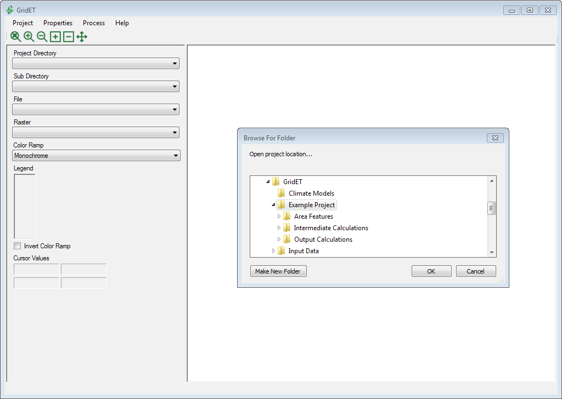
Screenshot 7. GridET Load Project Dialog

Settings
Currently, GridET (Version 1.1) supports changing the climate model dataset directory.
Climate Model Directory
Full path to the climate model directory (first chosen upon project creation), which may be changed with the set dialog.
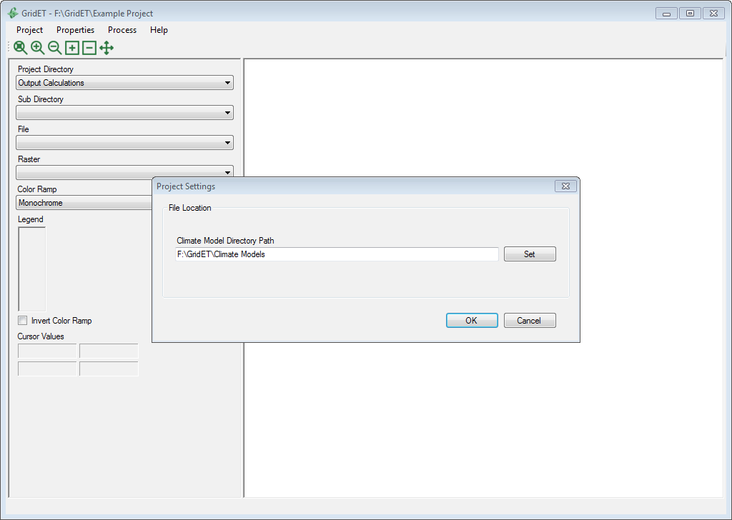
Screenshot 8. GridET Example Project Settings

Climate Model Directory
The climate model directory is a single directory (in contrast to the tiered project directory) that stores climate model raster chronologies in SQLite databases along with any auxiliary files. Within the current version (1.1), supported climate models include:
1. DAYMET (Precipitation Only)
2. NLDAS-2A

Curve Properties
This section along with Cover Properties are probably the most important working documentation for the user as the input values control how a land cover potential evapotranspiration is calculated. The curve properties are a subdataset of a land cover’s properties and could be included in the other dialog. However, different land covers can be created from the same curve information due to altered management on the ground (e.g., different alfalfa cutting dates for the same alfalfa crop curve), and only one dataset obviates redundant entries. Succinctly, curve properties define the land cover’s season, base variable, and fraction of that variable through curve coefficients. Theoretically, the base variable could be any input dataset that GridET has created, even something as bizarre as wind speed. GridET provides, through the NLDAS-2A climate model, reference evapotranspiration (ASCE Standardized and Hargreaves) and aerodynamic open water evaporation from upon which to base the potential evapotranspiration curve coefficients. Most likely one of these will be chosen; although, a relationship between mean air temperature or another input variable and a desired output may exist. This affords great flexibility creating land covers and also in future addition of base variables.
Curve Name
Unique name given to a curve dataset (must also be a valid filename).
Base Atmospheric Variable
A precalculated input dataset from a climate model upon which to reference curve properties in order to calculate potential evapotranspiration.
Seasonal Curve Type
If the land cover is cut throughout the year (as is hay) and the curve coefficients embody those cuttings, then choose ‘Has_Cuttings’ else ‘Full_Season’.
Initial Curve Type
Determines how the curve coefficients will be interpolated between the land cover initial period start and end dates. ‘Percent_Days’ indicates the curve will be stretched across the period, whereas ‘Number_of_Days’ assigns a coefficient every 10 days until termination (e.g., 0, 10, 20, 30,…days) allowing the user to simulate an early end-of-period due to frost or other event. The initial period represents start of year, green up, planting, or land cover initiation until midseason, full cover, flowering, or even end of season or end of year.
Initial Curve Coefficients (Table)
Even though GridET could support an arbitrary number of coefficients (as in the final curve period scenario) a fixed 11 coefficients is maintained from historical curve convention (0-100%). If the user desires a more flexible pattern, the initial period start and end dates could be manipulated in the cover properties to bypass this period altogether. If the seasonal curve type that was chosen ‘Has_Cuttings’, then the first curve represents the first cutting cycle, the second curve represents any following cycles, and the third curve represents plant growth after the last cutting.
Final Period Curve Type
Determines how the curve coefficients will be interpolated between the land cover final period start and end dates. ‘Percent_Days’ indicates the curve will be stretched across the period, whereas ‘Number_of_Days’ assigns a coefficient every 10 days until termination (e.g., 0, 10, 20, 30,…days) allowing the user to simulate an early end-of-period due to frost or other event. The final period represents midseason, full cover, or flowering until end of year, harvest, end of season, or dormancy.
Final Curve Coefficients (Table)
The final curve supports an arbitrary number of coefficients that can be applied to the percent or number of days curve type. If a land cover continues year-round with a fixed fraction of the base variable, as open water evaporation may, this curve could be left blank and the first curve used to handle the season’s calculations. If the seasonal curve type that was chosen ‘Has_Cuttings’, then the first curve represents the first cutting cycle, the second curve represents any following cycles, and the third curve represents plant growth after the last cutting.
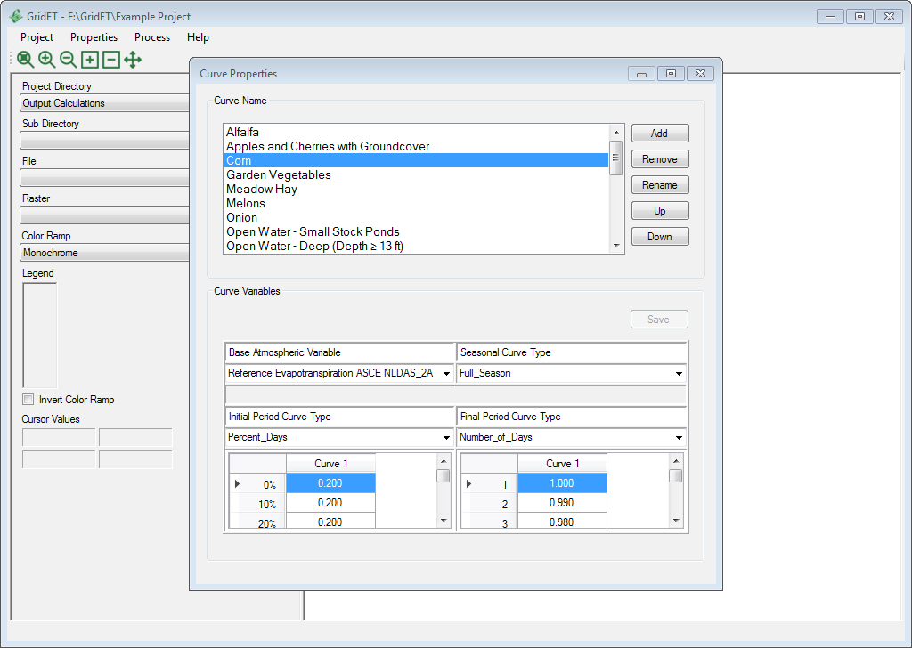
Screenshot 9. GridET Example Project Curve Properties

Cover Properties
Within the Cover Properties dialog, covers are created to represent different land surfaces for which to calculate potential and net potential evapotranspiration. While the selected curve dataset—which was previously created in the Curve Properties dialog—defines the reference variable, curve coefficients, and some behaviors, cover properties control the dates those relations start and end. Additionally, the method to calculate effective precipitation for the land cover is selected.
Cover Name
Unique name given to a land cover dataset (must also be a valid filename).
Curve Name
Name of curve from which the coefficients will be interpolated to calculate the land cover potential evapotranspiration.
Initiation Threshold
Value at which to offset the land cover season start date from January 1 of each year. This can be determined from a cumulative sum of Hargreaves evapotranspiration, a cumulative sum of growing degree days (32, 41, or 86-50 degrees Fahrenheit base), or a number of days. The cumulative sums based on atmospheric conditions allow dates to vary across a region and fluctuate from year-to-year. It should be noted that a good soil temperature estimation (currently absent in GridET Version 1.1) would be a good model to determine initiation for vegetation. In the present scenario, a last spring frost (air) temperature is chosen to constrain the chosen initiation date. If a land cover’s season spans the entire year, an initiation threshold of 0 days and an improbable last spring frost (e.g., -100 degrees Fahrenheit) may be selected.
Intermediate Threshold
Value at which to offset land cover intermediate date (end of initial period curve, start of final period curve the day after) from the initiation date. This can be determined from a cumulative sum of Hargreaves evapotranspiration, a cumulative sum of growing degree days (32, 41, or 86-50 degrees Fahrenheit base), or a number of days. The cumulative sums based on atmospheric conditions allow dates to vary across a region and fluctuate from year-to-year. A killing frost (air) temperature is also used as an early end of season if the intermediate threshold has not been reached. If a land cover’s season spans the entire year, an intermediate threshold of 366 days and an improbable killing frost (e.g., -100 degrees Fahrenheit) may be selected.
Termination Threshold
Value at which to offset land cover termination date from the intermediate date. This can be determined from a cumulative sum of Hargreaves evapotranspiration, a cumulative sum of growing degree days (32, 41, or 86-50 degrees Fahrenheit base), or a number of days. The cumulative sums based on atmospheric conditions allow dates to vary across a region and fluctuate from year-to-year. A killing frost (air) temperature is also used as an early end of season if the termination threshold has not been reached. If a land cover’s season spans the entire year or if the land cover is represented only by the initial period in the curve coefficients, a termination threshold of 0 days may be selected to forgo the final period.
Cutting Intermediate Threshold
Value at which to offset land cover cutting intermediate date from the last cycle end date or cutting. When a land cover’s curve ‘Has_Cuttings’, the season is modeled by multiple initial and final periods until a killing frost. After the first cycle (where dates are determined from the initial, intermediate, and termination thresholds), additional cycle dates are controlled by the cutting intermediate and cutting termination thresholds. The cutting intermediate threshold functions like the intermediate threshold described above.
Cutting Termination Threshold
Value at which to offset land cover cutting termination date from the cutting intermediate date. When a land cover’s curve ‘Has_Cuttings’, the season is modeled by multiple initial and final periods until a killing frost. After the first cycle (where dates are determined from the initial, intermediate, and termination thresholds), additional cycle dates are controlled by the cutting intermediate and cutting termination thresholds. The cutting termination threshold functions like the termination threshold described above.
Spring Frost Temperature
Value of minimum daily air temperature (degrees Fahrenheit) from which the last spring frost date is determined (until maximum day 200), which postpones the land cover initiation date for the year even if the initiation threshold has been reached. If a land cover is not affected by frost, then an improbable temperature may be chosen (e.g., -100 degrees Fahrenheit).
Killing Frost Temperature
Value of minimum daily air temperature (degrees Fahrenheit) from which the first fall frost date is determined (after day 200) at which to terminate potential evapotranspiration calculations for the year even if the termination threshold has not been reached. If a land cover is not affected by frost, then an improbable temperature may be chosen (e.g., -100 degrees Fahrenheit).
Effective Precipitation
Method to account for precipitation when calculating land cover net potential evapotranspiration. Currently (Version 1.1), four options exist: ‘None’, ‘80_Percent’, ‘100_Percent’, and ‘USDA_1970’. The first three subtract a flat percentage (0-100) of precipitation from the potential evapotranspiration, while the USDA method relates the total monthly precipitation to total potential evapotranspiration to come up with a value of effective portion of precipitation (ranging from 0-100 percent).
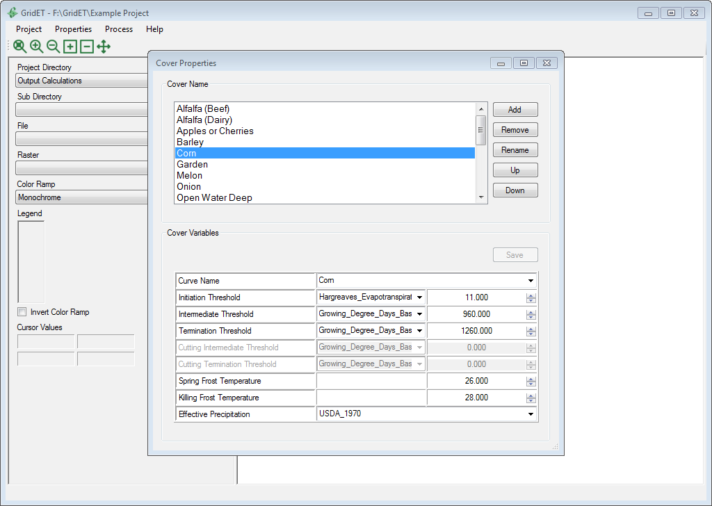
Screenshot 10. GridET Example Project Cover Properties

Import
Because land cover properties may be shared among multiple GridET projects or a previous dataset may be a good place to start with a new project, an import dialog provides copy and paste functionality. The curve and cover properties are stored within two tables in the ‘Project Details.db’ SQLite database file, and the copy function will insert or overwrite any curves and covers found into the loaded project from the selected project. Note: Once the operation is completed, any overwritten values are lost, so it is a good idea to manually backup the ‘Project Details.db’ database file. Since the import routine only looks for the ‘Project Details.db’ in the project directory, the backup could be moved to a different directory and reloaded.
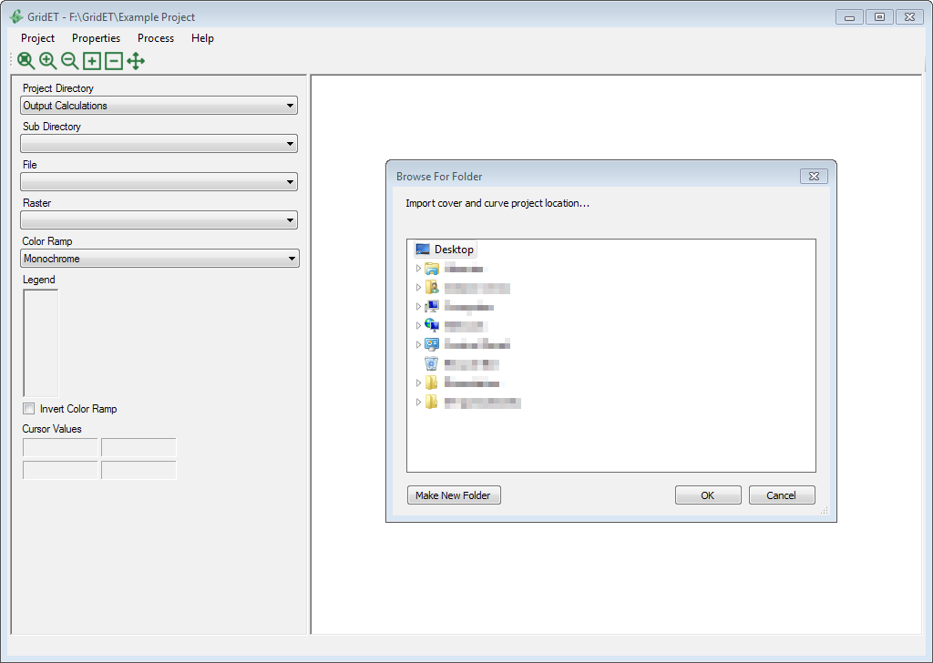
Screenshot 11. GridET Curve and Cover Property Import Dialog

Climate Model Download
In order to estimate evapotranspiration over a wide area, spatial measurements must either be collected and/or modeled. With Earth void of an apparatus capable of scanning the atmosphere for changes in the flux of H20 vertically and horizontally with sufficient accuracy and resolution, the next best dataset are the weather parameters derived from satellite and ground measurements modeled to represent that flux. GridET uses surface-based raster measurements of humidity, solar radiation, air pressure and temperature, and wind speed to model reference evapotranspiration and aerodynamic evaporation of open water. In addition, precipitation is included from which to calculate net evaporative potential (upward evapotranspiration minus downward precipitation). Currently (Version 1.1), the mainland United States is supported by two surface climate models: DAYMET and NLDAS. Each climate model is securely accessed through a free authentication service and readable by GDAL. To conserve bandwidth, space, and download time, these climate model datasets can be shared among GridET projects by referencing the directory in which they are housed. Each GridET project has the capability of updating the climate models, but this should not be done simultaneously as writes may be repeated by another project or create a deadlock if asynchronous writers try to access the SQLite database at the same time.

EarthData Authentication
Previously (Version 1.0), the weather drivers consumed by GridET were distributed via anonymous file transfer protocol (ftp) that provided simple and unimpeded access. This changed in the fall of 2016 when U.S. federal agencies united together to provide a universal service for authenticating clients. Support for storing cookies in a web request was added to GridET to complete the secured (https) file download. In order to use the feature, an account must be registered at https://urs.earthdata.nasa.gov/. Any desired datasets must also be explicitly added (for Version 1.1, NLDAS-2A and Daymet) by clicking a checkbox. Then, the username and password may be entered into the download dialog, as shown in the screenshot.
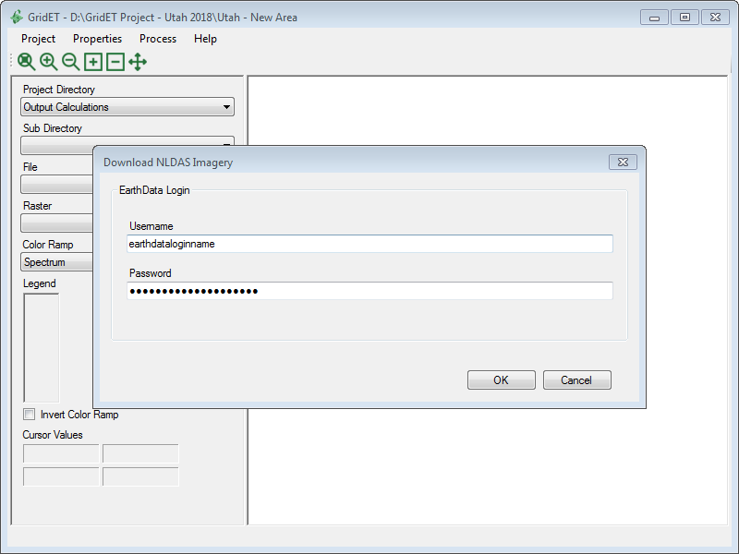
Screenshot 12. EarthData Login Dialog

DAYMET
Website: http://daymet.ornl.gov/
DAYMET models daily variables of day length, precipitation, solar radiation, snow water equivalent, maximum and minimum air temperature, and water vapor pressure on a 1 kilometer grid over much of North America. These are stored by year for each variable in a netCDF file or retrievable via a THREDDS server on the Oak Ridge National Laboratory website. Although DAYMET could be used to estimate reference evapotranspiration on a daily basis, the greater temporal resolution of NDLAS was employed for that purpose. Since DAYMET represents the extremes of arid and irrigated conditions or anything in between, the model would have to be adjusted to represent reference conditions. Only the precipitation is used by GridET as a high spatial resolution option.
Through a download dialog and authentication from an EarthData account, annual precipitation netCDF files are downloaded temporarily to disk and daily rasters extracted and converted to GeoTIFF format for a submitted date range. These are then stored within an SQLite database in the climate model directory for use in GridET projects.
Dates
Shows online directory, previously downloaded, and user-defined current download climate dataset periods. If the current download date range overlaps what has already been downloaded, the rasters will be overwritten.
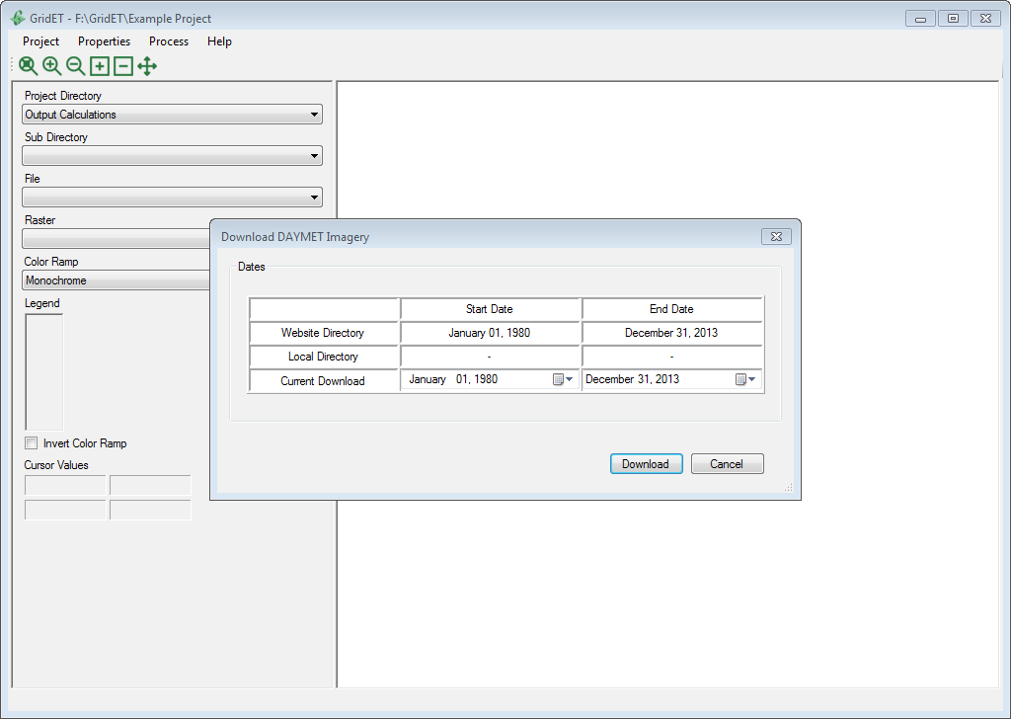
Screenshot 13. GridET DAYMET Climate Model Download

NLDAS
Website: http://ldas.gsfc.nasa.gov/nldas/
Forcing File A of the North America Land Data Assimilation System Phase 2 (NLDAS-2A) models hourly variables (among others) of precipitation, shortwave downwards radiation, air temperature and pressure, specific humidity, and the orthogonal wind vectors on a 1/8 latitude and longitude degree grid centered on the conterminous United States. Hourly parameters are stored in GRIB raster files and can be downloaded via EarthData authentication from a website hosted by NASA. NLDAS is mainly an interpolation of another model, the North American Regional Reanalysis (NARR, a 32 kilometer grid over North America) that is an amalgamation of surface, aerial, and satellite datasets. Even though the loss of microclimate detail as a result of the aggregation and then back-interpolation of surface meteorological measurements may seem detrimental to evapotranspiration estimation, the dissolution of real extreme conditions made it easier for adjustments to represent uniform reference conditions. GridET’s current (Version 1.1) configuration uses NLDAS-2A to estimate aerodynamic evaporation over open water, reference evapotranspiration, and growing degrees and also outputs the input meteorological variables.
Through a download dialog, hourly GRIB files are downloaded for a given date range and immediately stored in the same file format in an SQLite database in the climate model directory for use in GridET projects. Separate terrain raster files are downloaded and stored in GeoTIFF format for use in parameter interpolation to project locations.
Dates
Shows online directory, previously downloaded, and user-defined current download climate dataset periods. If the current download date range overlaps what has already been downloaded, the rasters will be overwritten.
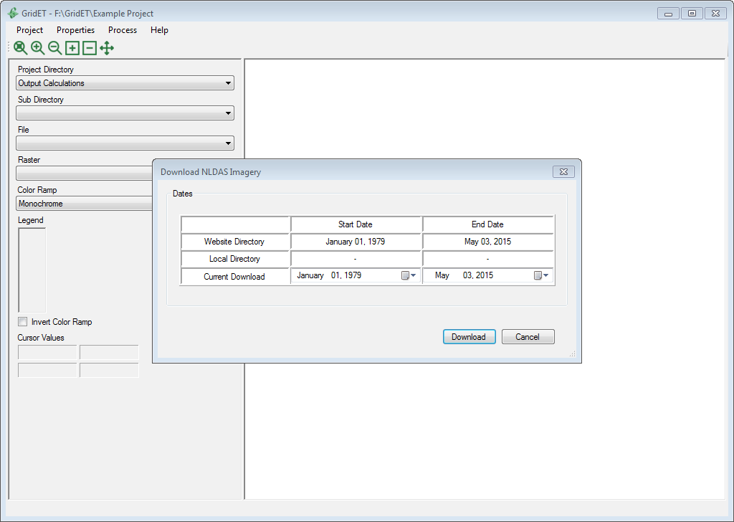
Screenshot 14. GridET NLDAS Climate Model Download

Others
Other untested climate models could be added to GridET for future calculations and as alternative evapotranspiration estimates. For example, PRISM is another climate dataset more or less equivalent to DAYMET but on a 4 kilometer grid. Satellite imagery could also be used in actual evapotranspiration calculations, which may include AVHRR, MODIS, and LANDSAT. U.S. soil databases, STATSGO or SSURGO, could be added for a depletion calculation. Further, the National Elevation Dataset (NED) could be downloaded to eliminate the need for an input elevation dataset in a GridET project creation.

Evapotranspiration Calculation
Over the past century, many methods have been proposed to estimate the water use of vegetation and/or surface evaporation from which GridET uses a select few. The purpose of this section is not to review their different strengths and weaknesses in theory and application but to document the routines in GridET. Methods included are the ASCE Standardized equation (Allen, 2005), Hargreaves equation (Hargreaves and Samani, 1982), aerodynamic water surface evaporation (Allen and Robison, 2009), and a solar positioning algorithm (Reda and Andreas, 2004). When the program alludes to reference evapotranspiration, it includes in its definition open water evaporation as calculated by the aerodynamic method. In the strictest sense, this definition is wrong but offers greater clarity to the user in grouping the calculations. The same is true for what is labeled as potential and net potential evapotranspiration. An example would be net lake evaporation being labeled ‘Deep Open Water Net Potential Evapotranspiration’ on output.
Evapotranspiration calculated at a raster pixel is influenced by its topography and climate and is valid for a horizontal surface. Before an output evapotranspiration dataset can be integrated in a mass balance model, the values should be adjusted for slope (more area on an angle). The result can be an increase of around 1-25 percent in steeper terrain, while moderate grades can be somewhat negligible with increases under a percent, and near-horizontal slopes are practically the same. Like the slope adjustment, evapotranspiration calculations themselves are tied to the terrain with higher resolutions providing much greater detail in mountainous areas with the same resolution excessive in flatter areas.

Reference Evapotranspiration
Reference evapotranspiration calculations comprise loading of input climate dataset parameters; unit conversion, terrain adjustment, and spatial interpolation of those parameters to the GridET project area; calculation of any necessary minimums, means, and maximums of parameters; and calculation of any outputs from those parameters (e.g., reference evapotranspiration, open water evaporation, growing degree days). Input parameters for a climate dataset may include air temperature and pressure, humidity, precipitation (for use in net potential evapotranspiration calculations), wind speed, and solar radiation. For a GridET project, the output time step for reference calculations is daily. Currently supported input climate datasets (Version 1.1) are DAYMET and NLDAS, and the following describes the calculation process unique to each dataset.
DAYMET
Only precipitation is output from this dataset. Since the netCDF files were converted to GeoTIFF on download, the daily total precipitation rasters are loaded from the DAYMET climate model database and bilinearly interpolated to match the extent and resolution of the project area. No terrain adjustments are applied.
NLDAS
Hourly ASCE Standardized long reference evapotranspiration and aerodynamic open water evaporation and daily Hargreaves reference evapotranspiration, precipitation, and growing degree days are calculated from the hourly NLDAS input data and the hourly values summed or averaged to daily values. Beyond the procedures in the ASCE Standardized equation manual (Allen, 2005), GridET replaces hourly extraterrestrial solar radiation integrations with 15 minute instantaneous values including slope adjustment (Reda and Andreas, 2004) averaged to hourly values that are used to adjust NLDAS solar radiation (Allen et al., 2006) for direct, diffuse, and reflected radiation in the interpolation process from nearby NLDAS pixels to the project pixel. NDLAS air pressure is input instead of using the static site estimation. Air temperature and pressure are adjusted for elevation between the NLDAS pixel and the target project pixel according to the NLDAS dataset procedure described in Cosgrove et al. (2003). All terrain adjustments are applied before a bilinear interpolation between the surrounding NLDAS pixels and the project pixel. Wind vectors are combined after the interpolation to obtain the magnitude of the wind speed.
An aridity adjustment was developed from comparing modeled NLDAS temperature and humidity to counterpart variables measured by electronic weather stations located in well irrigated conditions within the state of Utah. This is needed within a semi-arid or arid climate to adjust drier and hotter conditions to represent the cooler and more humid conditions of an irrigated or reference environment. A daily and seasonal least squares relationship was developed from the error between the modeled and measured temperatures and humidity (based on work by Lewis et al., 2014) and applied to the interpolated project pixel. Relative humidity was limited post adjustment to no less than 7 percent and no more than 100 percent.
 | (1)
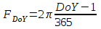 | (2)
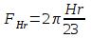 | (3)
Where is the error adjustment applied to the variable (in Fahrenheit degrees for air temperature and percent for relative humidity), and are the seasonal and daily sinusoidal values, is the Julian day of year, is the beginning time of an hour (0 through 23), is the value of the variable itself, and the constants are what was derived from the model-measurement comparison in the following table.
Table 2. Air Temperature and Relative Humidity Seasonal and Daily Coefficients as Derived from a Least-Squares Relationship between Modeled NLDAS Values and Weather Station Measurements Located within Irrigated Areas in Utah
Air Temperature | 1.58 | 0.59 | -1.53 | -3.73 | 1.4 | 0.0551
Relative Humidity | -21.9 | 0.78 | 3.55 | 11.6 | -5.05 | 0.274

An air temperature lapse rate was developed by comparing monthly average NLDAS air temperatures to weather station groupings researched by Strong et al. (2017). This relationship was substituted for the standard lapse rate that NLDAS uses and that was included in Version 1.0. Applied during the bilinear interpolation of air temperature, the lapse rate is an adjustment for elevation. Therefore, it only significantly affects areas of differential terrain. Monthly estimates were interpolated to daily values as shown in the following figure.
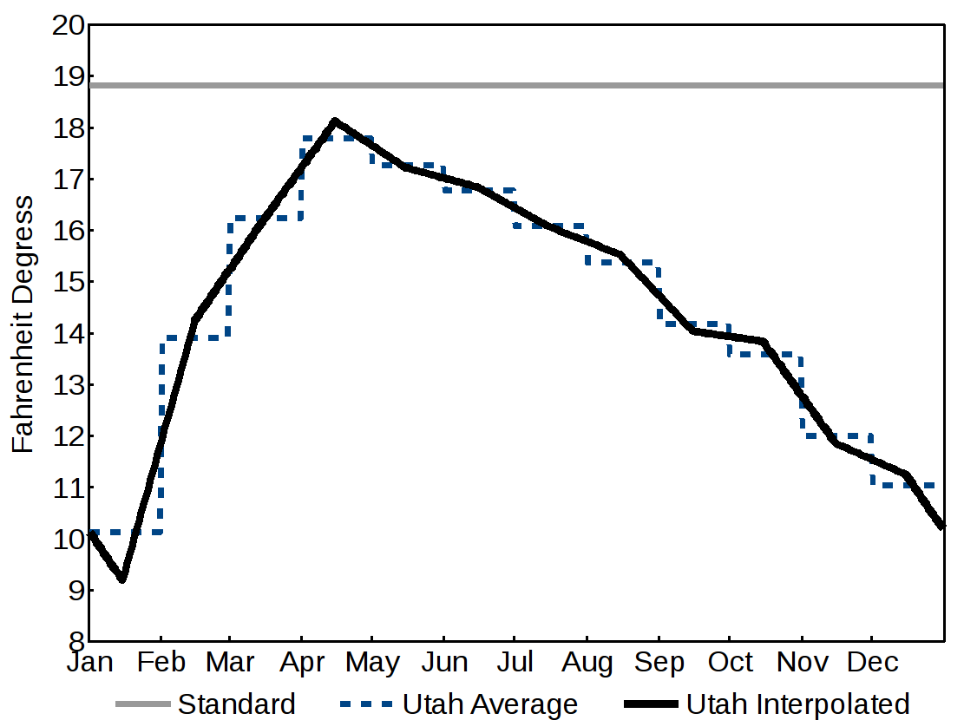
Screenshot 15. GridET Example Project Cover Reference Evapotranspiration Calculation
To control overestimation due to high wind speed values in the ASCE Standardized equation, hourly wind speed values were limited to 5.5 mile/hour corresponding to a daily maximum of 132 miles—a value derived from research by Hill et al. (2011).
By calibrating the above relationship for temperature, the solar radiation routine, and for a long reference, Hargreaves equation took on the following form.
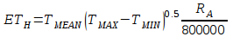 | (4)
Whereis long reference evapotranspiration (inches/day),is the daily mean hourly temperature (Fahrenheit),is the daily maximum hourly temperature (Fahrenheit),is the daily minimum hourly temperature, andis the daily total extraterrestrial averaged from 15-minute instantaneous calculations (Langleys).
Aerodynamic water surface evaporation is calculated for each project pixel from adjusted and interpolated NLDAS parameters according to the method outlined in Allen and Robison (2009). Two differences include hourly calculations summed to a daily output and a water vapor bulk transfer coefficient equal to 0.0014.
Growing degree day calculations are determined by subtracting a base (32 and 41 degrees Fahrenheit) from the average of maximum and minimum hourly temperatures limited to a minimum value of 0 Fahrenheit degrees. A special case, normally designated the 86-50 method for corn, was calculated with the maximum and minimum hourly temperatures limited each between 86 and 50 degrees Fahrenheit, averaged, and then subtracted by 50 degrees Fahrenheit. In all calculations, since the hourly maximum and minimum average temperature do not correspond exactly to the daily maximum and minimum temperatures, NLDAS growing degree day results will vary slightly than if calculated with the extreme values.
NLDAS precipitation is directly interpolated (bilinear) to the GridET project pixels.
Climate Dataset Selection
Checked list of climate datasets which may be included in reference evapotranspiration calculations. Currently, GridET (Version 1.1) only supports DAYMET and NDLAS. If selected climate dataset periods don’t align, only the intersected time period is shown.
Dates
Shows climate, previously calculated, and user-defined current calculation dataset periods. If the current calculation date range overlaps what has already been calculated, the rasters will be overwritten.
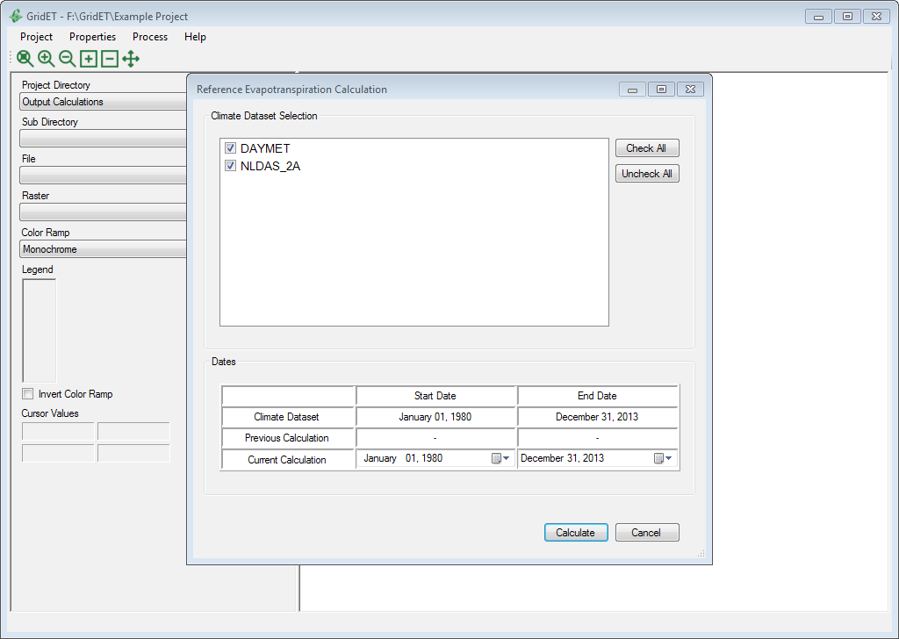
Screenshot 16. GridET Example Project Cover Reference Evapotranspiration Calculation

Potential Evapotranspiration
Potential evapotranspiration represents the maximum amount of transpiration and evaporation that would occur at a location under atmospheric demand for a given land cover if water was not wanting. As opposed to the specific procedures and custom routines applied to each climate model in the reference evapotranspiration equations, the potential evapotranspiration calculation is the same for all datasets. Potential evapotranspiration is calculated on a daily time step for a whole calendar year at a time. Because of some curve and cover property requirements which define each land cover, curve interpolations cannot be completed until the end date is known. This means sub annual calculations could occur once the initial period end date, final period end date, or a cutting intermediate or termination date (if the land cover ‘Has_Cuttings’) has been reached. But, this more complex functionality was not added to GridET (Version 1.1). Instead, full year input must be available and sub portions may be output from it. Potential evapotranspiration within GridET is calculated by ‘crop coefficient’ method by taking the variable fraction of a reference variable all season. This daily fraction can be constant or zero and is interpolated by the curve coefficients for a given land cover within a determined date range. Start and end dates are determined from an offset of days, accumulated growing degrees days, or accumulated Hargreaves reference evapotranspiration.
Cover Selection
Checked list of land cover datasets which may be included in potential evapotranspiration calculations. If selected cover periods don’t align, only the intersected time period is shown.
Dates
Shows reference evapotranspiration, previously calculated, and user-defined current calculation dataset periods. If the current calculation date range overlaps what has already been calculated, the rasters will be overwritten.
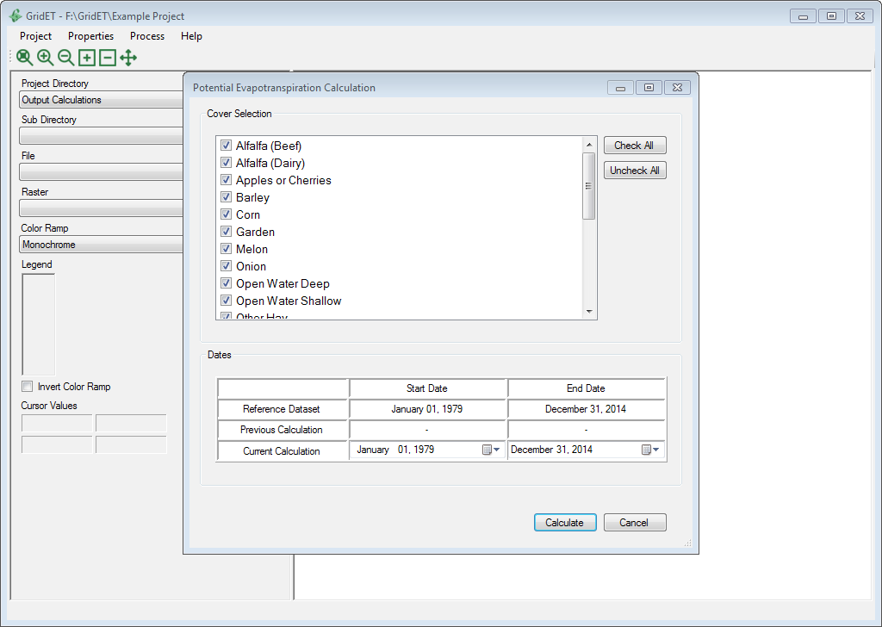
Screenshot 17. GridET Example Project Cover Potential Evapotranspiration Calculation

Net Potential Evapotranspiration
Net potential evapotranspiration is the potential evapotranspiration for a land cover minus effective precipitation. Effective precipitation is the portion of precipitation that actually becomes part of the evaporation or transpiration of a land cover and is governed by the option selected for the land cover in the cover properties dialog. Three of the four options calculate effective precipitation as a direct percentage (0-100) of the chosen climate model dataset precipitation. The ‘USDA_1970’ method (described in Bos, 2008) is a function of the potential evapotranspiration and the precipitation. In each case, the effective precipitation is divided by the ratio of the pixel sloped area to a horizontal plane in order to preserve the horizontal quantity of the output evapotranspiration. All calculations are on a monthly time step.
Cover Selection
Checked list of land cover datasets which may be included in net potential evapotranspiration calculations. If selected cover periods don’t align, only the intersected time period is shown.
Precipitation
Allows the user to choose which climate precipitation dataset will be used for estimating effective precipitation in the net potential evapotranspiration calculation. Currently, GridET (Version 1.1) supports DAYMET and NLDAS climate datasets.
Dates
Shows potential evapotranspiration, previously calculated, and user-defined current calculation dataset periods. If the current calculation date range overlaps what has already been calculated, the rasters will be overwritten.
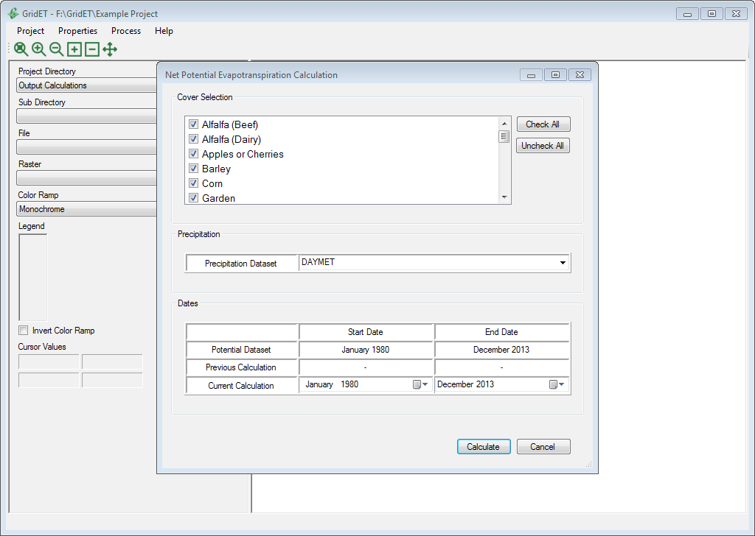
Screenshot 18. GridET Example Project Cover Net Potential Evapotranspiration Calculation

Geostatistical Calculation
Upon completion of the daily reference, potential, and net potential evapotranspiration calculations, monthly and annual sums or averages are totaled in a statistics table within the parameter SQLite database. These are ordered by year and can span several decades. Since monthly and annual statistics are easier to review than daily data across a wide region for scores of variables, routines to create summary raster images and polygon vectors were created. Even though individual months and annual totals can be directly accessed from a parameter database in their stored GeoTIFF format, these have been scaled from floating point values into 16 bit integers and compressed to reduce space requirements. Any GDAL driver should be able to recognize this scaling, but other programs’ TIFF drivers may not be able to read the file. GridET’s implementation internally recognizes the scaling and will automatically convert to floating point on loading any data. A raster period average tool was developed that not only exports the monthly and annual rasters in compressed floating point format but also will average over a number of years. These rasters values can be extracted by polygon vectors through a separate routine.

Raster Period Average
Even though period day of year averages could be calculated from each evapotranspiration calculation output except for net potential evapotranspiration which is on a monthly time step, it was deemed too much information for the user. Instead, monthly and annual totals—applicable to all parameters—were chosen for output. These parameter monthly and annual period averages are stored in a single GeoTIFF file as separate compressed bands. Band names are added, and band statistics are calculated to enable easy viewing and use in other GIS software. Each calculation output is stored in the GridET project output directory as a new directory with the start and end years making up the name separated by a hyphen.
Parameter Selection
Checked list of parameter datasets which may be included in raster period average calculations. If selected parameter periods of record don’t align, only the intersected period or record is shown.
Dates
Shows the parameter(s) and user-defined current calculation dataset periods. If the current calculation date range is already in the output calculations directory, the rasters will be overwritten.
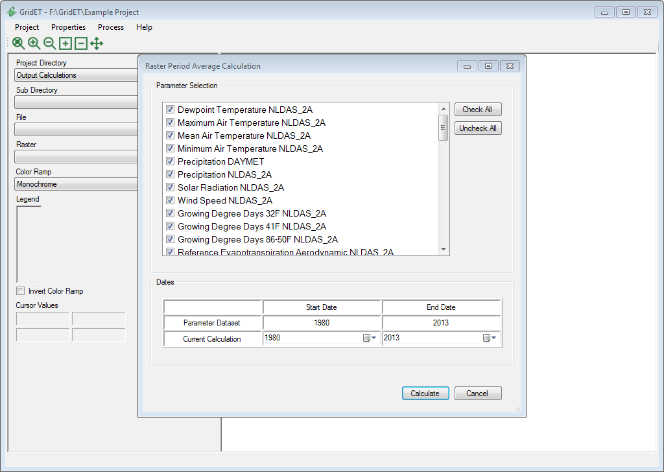
Screenshot 19. Period Average Calculation of GridET Example Project Parameters

Extract by Polygon
While estimated potential evapotranspiration for many land covers over a region is useful, a more practical output would be one dataset combining the different rasters for corresponding zones. Within GridET, this is done by extracting and averaging raster values located within polygons from an input vector dataset or by bilinear interpolation to the polygon centroid if no raster value falls within the polygon.
Input Polygon Dataset Path
Full path to a polygon vector dataset in which to extract monthly and annual raster values. Vector formats in GDAL 2.0 are supported minus non free externally linked libraries.
Input Polygon Dataset Cover Relate Field
Field in the input polygon dataset that relates to GridET output raster names. GridET (Version 1.1) limits shown fields to those with no more than 1000 unique values.
Calculation Period
Selected directory from a list of previously calculated raster period averages to be extracted to the input polygon vector dataset.
Polygon-Raster Relation Table
Once a cover relate field and calculation period has been selected, a table will appear where rasters may be related to the unique values contained within the cover relate field.
Output Polygon Dataset Path
Full path to output polygon vector dataset in shapefile format.
Since the GDAL/OGR drivers vary which read the input polygon files, the intermediate vector dataset (an SQLite database) is created as a copy of the original immediately upon load. This is to standardize the SQL search of unique values within the polygon dataset attribute fields with the SQLite driver a more reliable and potentially faster alternative. The overall operation may take some time though if the dataset is large.
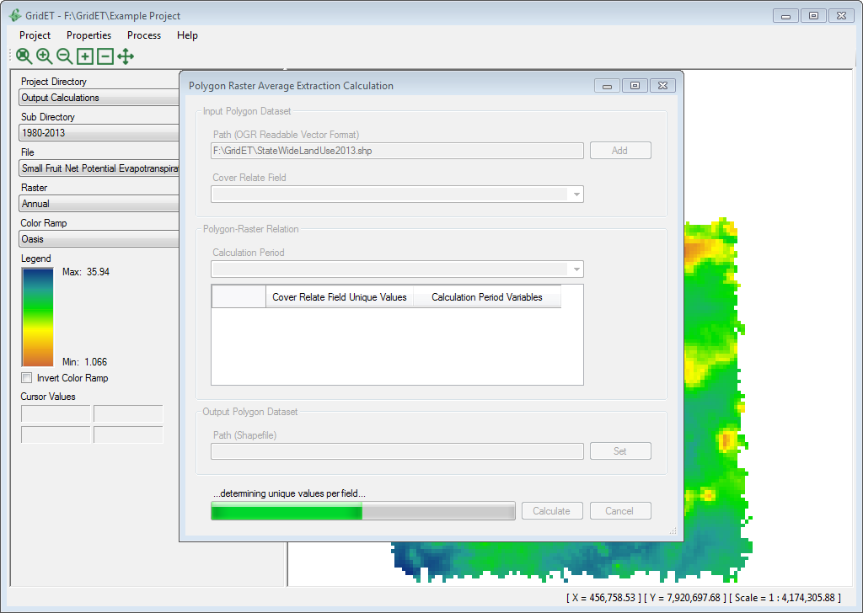
Screenshot 20. Loading of Polygon Vector for Extraction of GridET Example Project Parameters
Once the input polygon load is completed, the cover relate field may be chosen along with the calculation period to populate the polygon-raster relation table. As each unique attribute value is inserted, a sensitivity check is performed on the names of the raster datasets to determine which one most closely matches. The closest match that occurs first alphabetically is then added to the Calculation Period Variables column with the intent to spare the user the hassle of having to choose each item. Saved matches or a learning algorithm is not included.
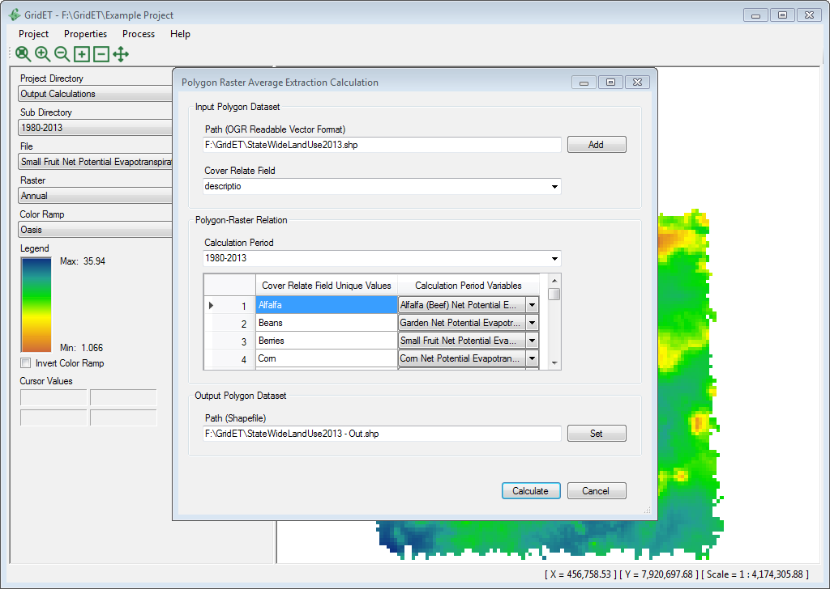
Screenshot 21. Relate Assignment between Polygon Vector Field and GridET Example Project Parameters

Process Scheduler
Running GridET daily to keep a project’s calculations in sync with a climate model dataset would be tedious, and periodic updates would require either faster and more expensive hardware or slower calculation times with downloads being a function of internet speed. Therefore, a solution was created to automate these processes daily at a user-defined time, which could be a time when no data access is envisioned (like the early morning hours). Without too many options, the process scheduler should be straightforward to understand: just select the desired processes and time to run and click [Start]. When the next appointed time is reached, the routine begins the download and calculations in the order they appear. Actual dialogs are created and silently loaded with the default settings, and processes are begun if the dataset is not ‘up-to-date’. Progress bar values and updates are copied from the process dialog to process scheduler until each process completes. A timer is set to trigger the next automation unless the last automation took longer than 24 hours whereupon the automation repeats immediately. If the dialog is closed while automation has already started, it remains hidden until the next time the user reopens it. This is to enable interaction of the output; although, it is recommended to run the process scheduler in its own instance in case the application shuts down due to an error.
Process
Checked list of processes in GridET download and calculation routines that may be automated.
Time
Hour and minute that automation of selected processes should begin each day.
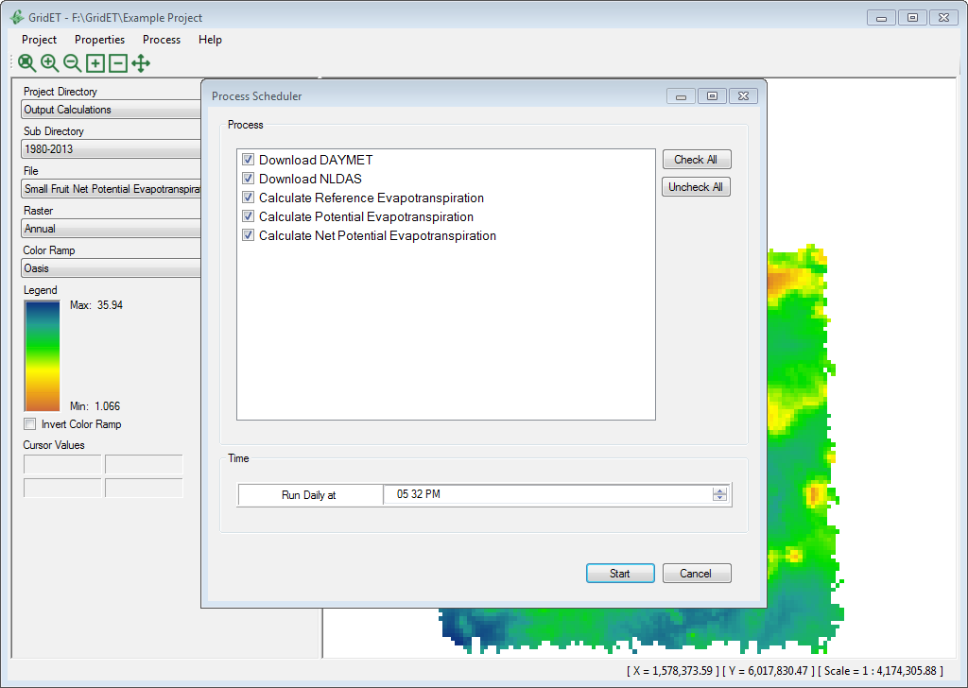
Screenshot 22. GridET Process Scheduler

Map Viewer
Aside from the main importance of the accuracy of calculated output in GridET, the second most important function would be to view and analyze the output for accuracy. A package was added to the GridET interface to allow the user to visualize the project rasters both on a daily and on a period time step. Functions of panning and zooming create a full GIS viewing experience from within GridET. The map viewer enables quick inspection of pixel values with options to change the color scheme. Raster images were created from an open source library bundled with GDAL named MapServer.

MapServer
MapServer is a GIS viewing or map creation library for raster and vector data mainly built on top of GDAL reading capabilities. Developed as an open source alternative for web mapping, MapServer is quite mature and feature rich. Its uninhibited license permits inclusion in any project. Although GridET currently (Version 1.1) only utilizes the raster functionality, vectors could be easily added by appending to a MapServer map definition file or through manipulation of the runtime map object.
 |  | MapServer  http://mapserver.org/  License: MIT-Style

Raster Selection
Enabled when GridET is launched, the raster selection panel becomes populated with the directories, databases, and rasters of project when loaded. Its purpose is to allow the user to easily navigate directories to a desired raster, apply a color scheme, and view individual raster values.
Project Directory
Toggles raster selection at the GridET project Level 1 directories.
Sub Directory
Toggles raster selection at the GridET project Level 2 directories including project initialization, intermediate calculations, and output period calculations.
File
Toggles between rasters within the GridET project Level 3 directories.
Raster
Selects a raster band within a raster or a daily time step raster to be viewed.
Color Ramp
Switches the raster color ramp between preprogrammed color combinations.
Legend
Shows the raster color ramp, maximum and minimum ramp values (which are rounded up and down, respectively, to the fourth significant value to apply to each pixel), and allows the user to invert the ramp by clicking a checkbox.
Pixel Values
Displays the raster pixel values surrounding a cursor when it is hovering over the map.
Map Bar
Displays the X and Y coordinates of the cursor as it hovers over the map. Also included is the map scale.
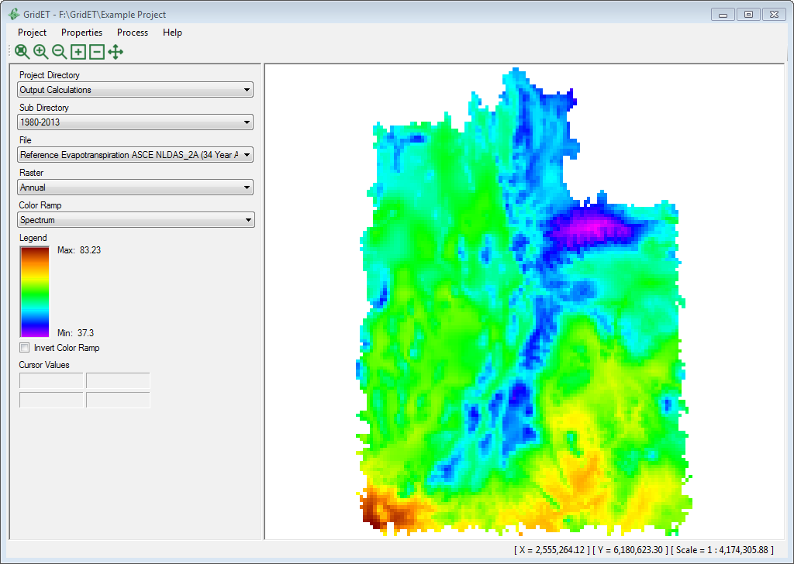
Screenshot 23. Raster Display in Map Viewer

Zoom and Pan
Located beneath the project menu is the map viewer toolbar, which holds buttons that may be selected to pan and zoom in and out of the map.
Zoom to Full Extent
Zooms the map to full raster extent and centers on display.
Fixed Zoom In
Zooms the map in by dividing the scale factor by two and centering on the current midpoint of the display.
Fixed Zoom Out
Zooms the map out by multiplying the scale factor by two and centering on the current midpoint of the display.
Zoom In From Rectangle
Zoom the map in by centering on a user-selected box on screen. Button should be deselected when finished.
Zoom Out From Rectangle
Zoom the map out by centering on a user-selected box on screen. Button should be deselected when finished.
Pan
Allows the user to pan around the raster map while keeping the same scale by clicking the direction on the side of the map where it is desired to move. Button should be deselected when finished.
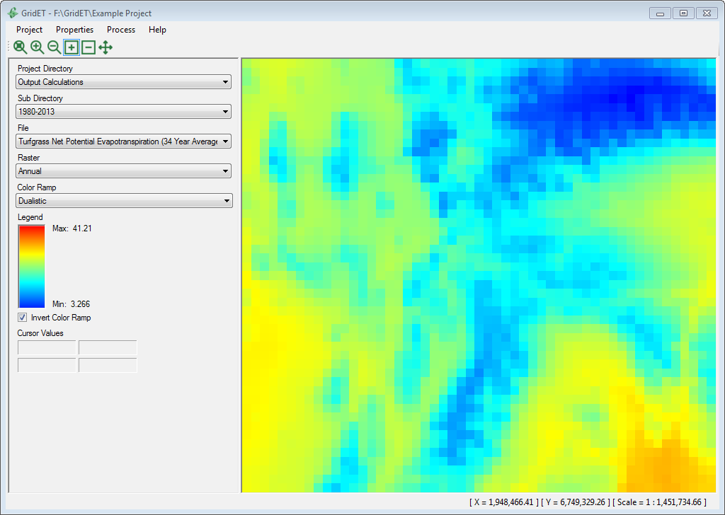
Screenshot 24. Zoom and Pan Functionality of Map Viewer

Help File
GridET Version 1.0 used an open source solution to automatically build a .chm Microsoft help file. The input (what you are viewing) was converted from a .docx format into htm files categorized by headings. In Version 1.1, the .chm format was dropped in favor of displaying directly with html. Content can be viewed by selecting header nodes and searched.
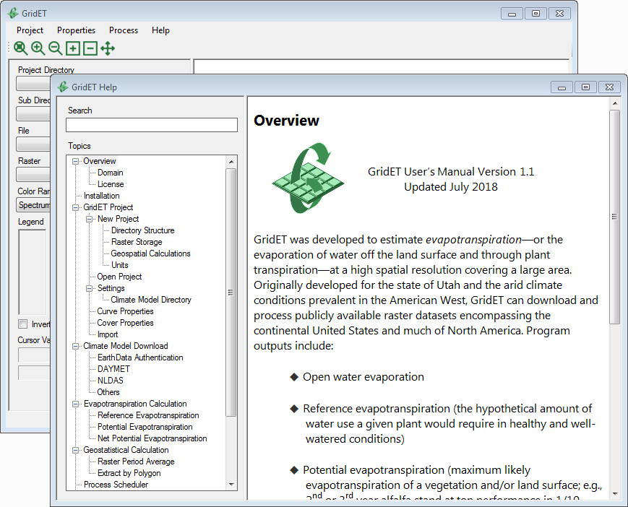
Screenshot 25. UtahET Help File

Abbreviations/Acronyms
ACID - (Atomicity, Consistency, Isolation, Durability) is a set of properties that guarantee that database transactions are processed reliably
DAYMET - gridded North American climate dataset distributed by Oak Ridge National Laboratory
DB - database
ESRI – (Environmental Systems Research Institute)
ET - evapotranspiration
GDAL – (Geospatial Data Abstraction Library)
GeoTIFF – georeferenced TIFF file
GIS – (geographic information system)
IDE – (integrated development environment)
LANDSAT - joint NASA/USGS land surface satellite program
MODIS – (Moderate Resolution Imaging Spectroradiometer) NASA satellites
NASA – United States (National Aeronautics and Space Administration)
NED – (National Elevation Dataset) maintained by the United States Geological Survey
NLDAS – (North American Land Data Assimilation System) is a gridded climate dataset with hourly resolution covering the continental United States
PRISM - gridded climate dataset of the United States provided by Oregon State University
QGIS - open source geographic information system
RAM - random-access computer memory
RDBMS - relational database management system
SQLite - public domain embedded structured query language library
SSURGO – (Soil Survey Geographic Database) [higher resolution] provided by the United States Natural Resources Conservation Service
STATSGO – (State Soil Geographic Database) [lower resolution] provided by the United States Natural Resources Conservation Service
TIFF – (Tagged Image File Format)

References
Allen, R. G. (Ed.). (2005). The ASCE standardized reference evapotranspiration equation. Amer Society of Civil Engineers.
Allen, R. G., Robison, C. W. (2009). Evapotranspiration and consumptive irrigation water requirements for Idaho: Supplement updating the time series through December 2008. Research Technical Completion Report: Kimberly Research and Extension Center, University of Idaho, Moscow, ID.
Allen, R. G., Trezza, R., Tasumi, M. (2006). Analytical integrated functions for daily solar radiation on slopes. Agricultural and Forest Meteorology, 139(1), 55-73.
Bos, M. G. (2008). Water requirements for irrigation and the environment. Springer Science & Business Media.
Cosgrove, B. A., Lohmann, D., Mitchell, K. E., Houser, P. R., Wood, E. F., Schaake, J. C., Robock, R., Marshall, C., Sheffield, J., Duan, Q., Luo, L., Higgins, R W., Pinker, R. T., Tarpley, J. D., & Meng, J. (2003). Real-time and retrospective forcing in the North American Land Data Assimilation System (NLDAS) project. Journal of Geophysical Research, 108(D22), 8842.
Hargreaves, G. H., Samani, Z. A. (1982). Estimating potential evapotranspiration. Journal of the Irrigation and Drainage Division, 108(3), 225-230.
Hill, R. W. (1994). Consumptive use of irrigated crops in Utah. Utah Agr. Exp. Stn. Res. Report, (145).
Hill, R. W., Barker, J. B., Lewis, C. S. (2011). Crop and Wetland Consumptive Use and Open Water Surface Evaporation for Utah. Utah Agr. Exp. Stn. Res. Report, (213).
Lewis, C. S., Geli, H. M., & Neale, C. M. (2014). Comparison of the NLDAS Weather Forcing Model to Agrometeorological Measurements in the western United States. Journal of Hydrology, 510, 385-392.
Reda, I., Andreas, A. (2004). Solar position algorithm for solar radiation applications. Solar energy, 76(5), 577-589.
Strong, C., Khatri, K. B., Kochanski, A. K., Lewis, C. S., & Allen, L. N. (2017). Reference evapotranspiration from coarse-scale and dynamically downscaled data in complex terrain: Sensitivity to interpolation and resolution. Journal of Hydrology, 548, 406-418.

